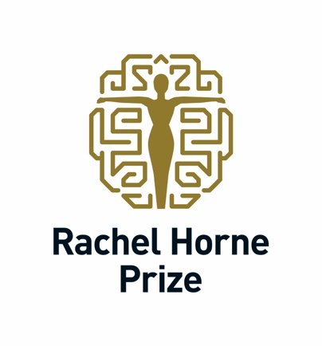

Applications open for 2026 Rachel Horne Prize recognising leadership in women’s MS research

Submissions open on International Women’s Day for prestigious US$40,000 international award

London, UK, 8 March 2026 - Applications are now open for the 2026 Rachel Horne Prize for Women’s Research in MS, the international award recognising an established female scientist whose research has significantly advanced care for women living with multiple sclerosis (MS).

Launched on International Women’s Day, the annual prize awards US$40,000 to a senior researcher demonstrating exceptional scientific contribution, leadership, and impact in women-focused MS research.

Applicants must hold an MD or PhD degree and have worked for more than 15 years at Assistant Professor level and, at the time of the application, hold the title of Associate Professor or Professor. Submissions should demonstrate the applicant’s leadership in women’s health research in MS and their measurable contribution to improving patient outcomes.

“Recognising the outstanding work senior women neuroscientists make to health-related research in MS and leadership remains imperative,” said Rachel Horne, founder of the prize. “It is a privilege to support and honour those who have dedicated their professional lives to researching issues faced by women with MS.”

Applications require a two-page submission in English outlining:
- the applicant’s career context
- why they should be considered for the 2026 Prize
- their key accomplishments
- their vision for how the field is evolving
- the next steps in MS research

The recipient will record a special episode for the European Committee for Treatment and Research in Multiple Sclerosis (ECTRIMS) Podcast and present their work through global remote meetings and/or in-person events organised by International Women in MS (iWiMS).

The award will be presented at the 10th Joint ACTRIMS-ECTRIMS Meeting in Toronto, Canada, in October 2026. Applications close on 12 June 2026. Full eligibility criteria and application details are available via the online application portal at www.rachelhorneprize.com.

The review panel will include members of iWiMS. The prize money, to be used at the discretion of the recipient, is made possible through the Horne Family Charitable Fund and is supported by iWiMS, ECTRIMS, and the Americas Committee for the Treatment and Research in MS (ACTRIMS).

“iWiMS is delighted to partner with the Rachel Horne Prize in recognising the outstanding contributions being made by senior scientists,” says Marwa Kaisey MD, Chair of iWiMS. “Supporting the work of women researchers in MS is essential to sustaining diverse perspectives and ensuring equitable representation in scientific advancements that improve patient care and outcomes.”

Recipients include:
- Dr Kristen Krysko (2025), awarded the Rising Star Prize for research guiding treatment decisions during pregnancy and breastfeeding.
- Prof Kerstin Hellwig (2024), honoured for pioneering research improving understanding, safety, and healthcare for women with MS before, during and after pregnancy.
- Prof Rhonda Voskuhl (2023), recognised for her work investigating sex differences in MS susceptibility and progression in MS and identifying potential therapeutic pathways.

Editors Notes:

About Rachel Horne
Journalist and MS advocate Rachel Horne was diagnosed with multiple sclerosis in 2009. Drawing on her journalism background, she began researching the disease from a patient perspective and identified a significant gap in knowledge surrounding women’s health issues in MS, despite women accounting for approximately two-thirds of those diagnosed.

In response, she established the Rachel Horne Prize for Women’s Research in MS in 2023 through the Horne Family Charitable Fund. The Fund is administered by Aqueduct Foundation, a Canadian public charitable foundation that facilitates significant personal philanthropy.

About iWiMS
The International Women in Multiple Sclerosis network unites clinicians and researchers dedicated to advancing scientific discovery and improving care for people with MS and related disorders. Founded by women and supportive of all, iWiMS promotes meritocracy, diversity, parity, and innovation in MS research and clinical practice.

About ECTRIMS
The European Committee for Treatment and Research in Multiple Sclerosis is the world’s largest professional organisation dedicated to the understanding and treatment of MS.

About ACTRIMS
The Americas Committee for Treatment and Research in Multiple Sclerosis is a community of leaders across the United States and Canada focused on advancing research, education and collaboration in MS and other demyelinating diseases.

Media Contact
Sue Radford: sue@sueradfordassociates.com

Online
www.rachelhorneprize.com

 Rachel Horne

 @RachelHorne19
#RachelHornePrize #WomenInMSMatter

